PROJECT NAME: TRACK MY BUS
The Track My Bus is web application allows users to check real-time bus arrival timings at any Singapore bus stop.
Design Process
The app helps commuters plan their journey efficiently by displaying upcoming bus arrivals, and passenger service details.
Main Page
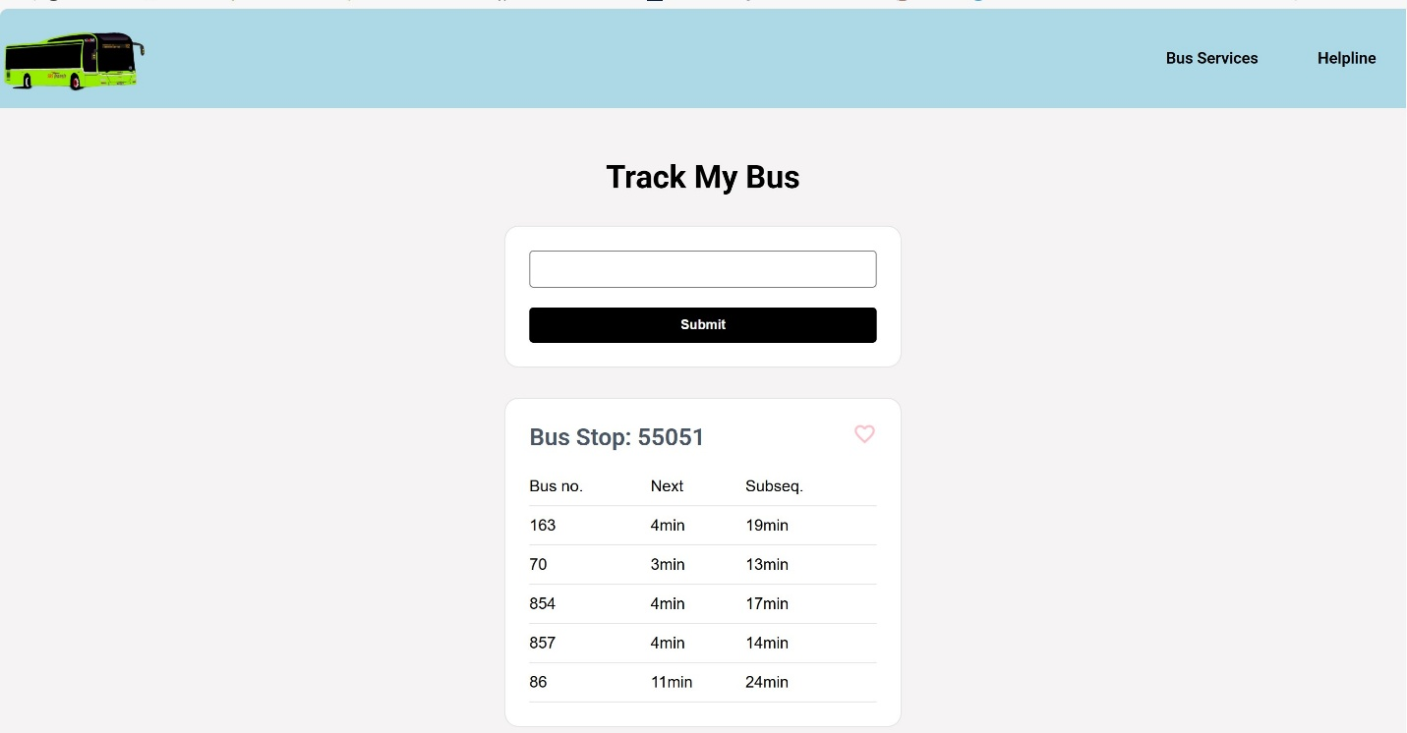
Dropdown Menu
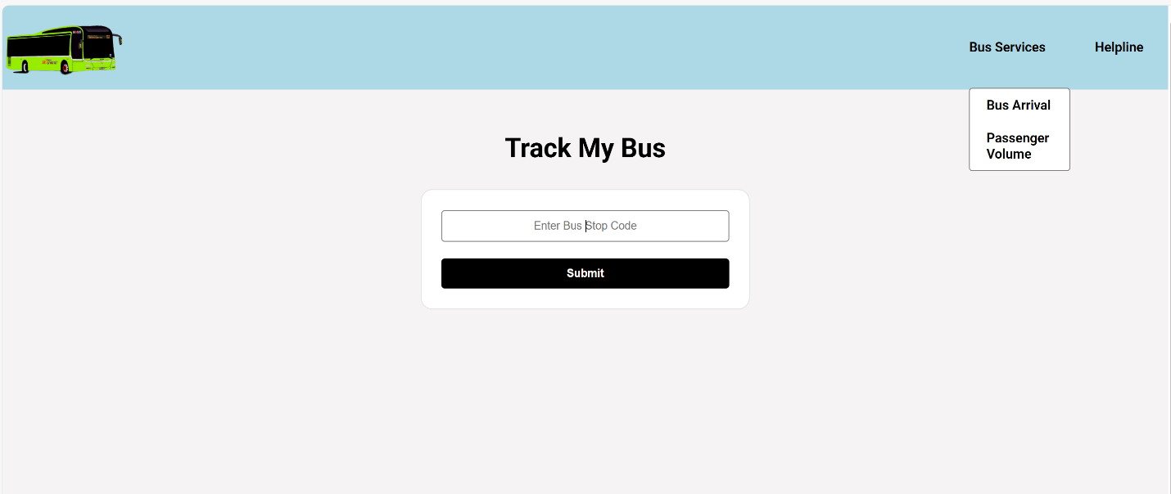
Features
User able to access following information through the app:
- Real-Time Bus Arrival Timings
Shows next three bus arrivals for each service.
- Search by Bus Stops Code
Search by bus stop code at nearby locations.
- Contact
Allow user to contact for authority for other information and clarification
- Passenger Volume service
Allow user to download bus service-related information.
Existing Features
- There are many applications get bus arrival status with similar feature.

Features Left to Implement
- Bus route map will be included into future updates.
- May be included weather updated Rain / Sunny to user to plane before home or office.

- Another feature idea
Technologies Used
- JavaScript
- Html
- Css
- LTA API- Bus Services API-
- API call through JavaScript server

Testing
- Track My Bus:
  - Go to the "Bus Services" page
  - Select “Bus Arrival” from the dropdown menu.
  - Enter Bus Stop Code No. into search box.
  - Submit the form with prefer bus code no.
  - Bus services arriving time will be display for the provided bus stop code.
  - Favorite icon for user to markup favorite bus stop.

Credits
- Facing issue with LTA API getting information.
- Not able call direct API call from the html page
- Web page working with most of the browsers and screen size as
- Concluded with JavaScript Server and html get updated by JavaScript.
Content
- The favorite icon copy from the following website
- https://fonts.google.com/icons
Media
- The photos used in this site were obtained from Bus Image and favorite icon downloaded from the following website
- https://landtransportguru.net/web/wp-content/uploads/2023/04/3003-131.jpg
- https://fonts.google.com/icons
Acknowledgements
- I received inspiration for this project from colleague

